भारत मौसम विज्ञान विभाग |  | India Meteorological Department
Tuesday 05th May 2026 (15th Vaisakha 1948 Saka)
Summary of observations recorded at 0830 hours IST: The Western Disturbance as a cyclonic circulation over north Pakistan & neighbourhood lay over Kashmir & neighbourhood at 2030 hrs IST of yesterday night. It then persisted over the same region at 3.1 km above m. s. l. with a trough aloft in middle and upper tropospheric westerlies with its axis at 5.8 km above m. s. l. roughly along Long. 72°E to the north of Lat. 28°N. The upper air cyclonic circulation over Haryana & neighbourhood persisted and seen at 1.5 km above m. s. l. An upper air cyclonic circulation lay over southeast Rajasthan & neighbourhood and extended upto 1.5 km above m. s. l. at 0530 hrs IST of today morning. It lay over southwest Rajasthan extended upto 1.5 km above m. s. l. at 0830 hrs IST of today. An upper air cyclonic circulation lay over central parts of East Uttar Pradesh at 0.9 km above m. s. l. at 0530 hrs IST of today morning. It then lay over East Uttar Pradesh at 0.9 km above m. s. l. at 0830 hrs IST of today. The upper air cyclonic circulation over East Madhya Pradesh & neighbourhood lay over central parts of Madhya Pradesh and extended upto 1.5 km above m. s. l. at 0530 hrs IST of today morning. It then lay over central parts of south Madhya Pradesh extended upto 1.5 km above m. s. l. at 0830 hrs IST of today. The trough from south Chhattisgarh to Manipur ran from the cyclonic circulation over central parts of Madhya Pradesh to Bihar at 0530 hrs IST of today morning. It then ran from the cyclonic circulation over central parts of south Madhya Pradesh to Bihar across north Chhattisgarh, southeast Uttar Pradesh and Jharkhand at 0.9 km above mean sea level. The north-south trough from Vidarbha to Comorin Area ran from central parts of Madhya Pradesh to Comorin area at 0530 hrs IST of today morning. It then ran from cyclonic circulation over central parts of south Madhya Pradesh to Gulf of Mannar across Vidarbha, Marathwada, Interior Karnataka and Tamil Nadu extending upto 1.5 km above m. s. l. A north-south trough ran roughly along Long. 89°E to the north of Lat. 21°N at 3.1 km above m. s. l. A fresh Western Disturbance is likely to affect Western Himalayan Region from 10th May, 2026. The trough from the upper air cyclonic circulation over Haryana & neighbourhood to northeast Arabian sea ran from Haryana to southwest Rajasthan at 1.5 km above m. s. l. at 0530 hrs IST of today morning. It then became less marked. The upper air cyclonic circulation over Central Assam & neighbourhood lay over northeast Bangladesh persisted and now seen at 0.9 km above mean sea level. became less marked. The upper air cyclonic circulation over interior Odisha & neighbourhood became less marked.
Maximum Temperature Departures (as on 04-05-2026): They are above normal (1.6°C to 3.0°C) at isolated places over Konkan & Goa, Kerala & Mahe and Assam; markedly below normal(< -5.1°C) at many places over Haryana-Chandigarh-Delhi, at a few places over Jammu-Kashmir-Ladakh-Gilgit-Baltistan-Muzaffarabad, Himachal Pradesh, Punjab, Uttar Pradesh, at isolated places over Uttarakhand, Madhya Pradesh, Mizoram; appreciably above normal(-5.0°C to -3.1°C) at a few places over East Rajasthan; at isolated places Bihar, Jharkhand, Odisha, Coastal Andhra Pradesh, Nagaland, Manipur, Tripura and Andaman & Nicobar; below normal (-3.0°C to -1.60°C) at a few places over Gujarat state, at isolated places over Chhattisgarh, Gangetic West Bengal, Meghalaya and Tamil Nadu. The highest maximum temperature of 44.2°C was reported at Brahmapuri (Vidarbha).
Thunderstorm accompanied with Squally/Gusty winds with speed reaching 50-90 kmph prevailed at isolated places over Jharkhand, Bihar, Punjab, Uttarakhand, Uttar Pradesh, Gujarat Region, Rajasthani, Gangetic West Bengal, Nagaland, Manipur, Mizoram & Tripura, Madhya Pradesh, Odisha with speed reaching 30-50 kmph prevailed at isolated places over Arunachal Pradesh, Assam & Meghalaya, Jammu-Kashmir, Haryana, Chandigarh, Vidarbha, Chhattisgarh, Maharashtra and Saurashtra & Kutch.
Hailstorm reported over Madhya Pradesh, Bihar, Jammu-Kashmir-Ladakh-Gilgit-Baltistan-Muzaffarabad, Himachal Pradesh, Uttarakhand, East Uttar Pradesh, East Madhya Pradesh, Bihar, Rajasthan.
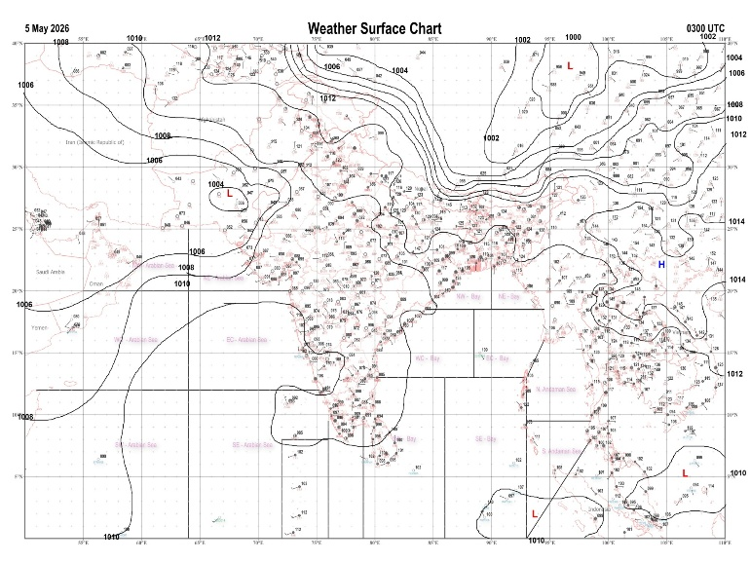 | 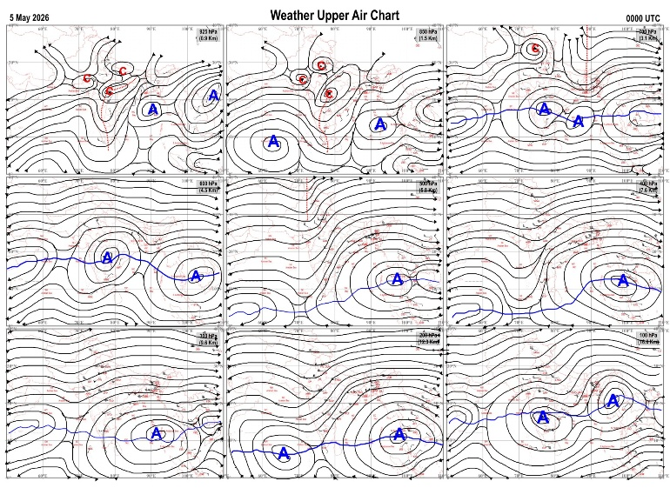
Fig.1. Analysed surface chart based on 03z observation | Fig.2. Analysed upper air chart based on 00z observation
V.K.Shripad
Scientific Officer ‘I’
CR & S Office, Pune  Issued at 1245 hrs. IST |  | Weather Forecasting Division  CR&S, Pune

Indian regions | Realised rainfall (chief amount in cm during past 24 hrs):
East | most places: West Bengal & Sikkim+ and Bihar  many places: Jharkhand+  a few places: Arunachal Pradesh, Assam & Meghalaya, Nagaland-Manipur-Mizoram-Tripura and Odisha+  Jhallong 10.3, Ghatia t.e. 9.9, Tenughat & Latehar balumat kvk AWS 8.2 each, Banarpal 7.5, Burnpur 7.0, Chauldhowaghat 6.3, Chouldhuwaghat ARG 6.1, Hajipur & Simri 5.9 each, Bagati, Kalyani smo & Dhamnagar 5.5 each, Jamui 5.0, Paradeep cwr 3.7, Jiribam AWS 3.1, Sabroom 2.9, Balurghat 2.5, Tuting 1.9, Lengpui 1.6, Ziro 1.3, Seppa & Guwahati AP 1.0 each, Jamshedpur 0.2.
North | many places: east Uttar Pradesh+ and Jammu-Kashmir and Ladakh  a few places: Uttarakhand, Himachal Pradesh and east Rajasthan  isolated places: west Uttar Pradesh, Haryana, Punjab and west Rajasthan  Fatehpur tehsil 7.2, Bansi tehsil 6.6, Poonch & Bijoliya SR 5.1 each, Udaipur-wati 4.3, Gorakhpur 4.1, Rajouri 3.5, Pali, Dharmsala & Bhilwara tehsil SR 3.2 each, Kangra AP 2.9, Churu & Churu tehsil SR 2.4 each, Uttar kashi 2.3, Barkot & Bathinda AWS 2.2 each, Bhatinda AMFU, Guler & Raj pura ARG 2.1 each, Banbasa & Ferozepur 2.0 each, Bhadra 1.9, Green field ps 1.5, Ndri kvk AWS 1.3, Mahroni & Delhi ridge 1.2 each, Aligarh 0.3.
Central | a few places: east Madhya Pradesh  isolated places: west Madhya Pradesh and Chhattisgarh  dry weather: Vidarbha  Kurwai 4.7, Nowgong 4.1, Nangur & Ambikapur 3.4 each, Kelhari 3.2, Badagaon dhasan 2.7, Guna-aws 2.6, Naigarhi 2.5, Shamshabad 1.4.
Peninsula | many places: Kerala+  a few places: Tamil Nadu+  isolated places: coastal Andhra Pradesh, Rayalaseema+ and south interior Karnataka  dry weather: Gujarat State, Konkan & Goa, Madhya Maharashtra, Marathwada, Telangana and coastal and north interior Karnataka  Ponmalai 9.8, Trp AP 9.4, Tiruchirappalli junctio 8.1, Sullurpeta 7.4, Angadipuram 7.3, Mancompu 7.1, Tada 5.9, Gundlupet 5.3, Karipur ap. 4.8, Begur 4.2, Vepada 3.1, Srungavarapukota 1.2.
Islands | isolated places: Andaman & Nicobar  dry weather: Lakshadweep  Car Nicobar 2.9.
Table-2 Forecast / warnings (distribution of rain / thundershowers) for 7 days (valid from time of origin upto 0830 hrsIST of next day)
Sr N. |  | Sub-division Name | Day 1 | Day 2 | Day 3 | Day 4 | Day 5 | Day 6 | Day 7 | Sr. No. | Sub-division Name | Day 1 | Day 2 | Day 3 | Day 4 | Day 5 | Day 6 | Day 7
 |  |  | 05 May | 06 May | 07 May | 08 May | 09 May | 10 May | 11 May |  |  | 05 May | 06 May | 07 May | 08 May | 09 May | 10 May | 11 May
 | 1 | Andaman Nicobar Islands | S  | I  | S | S | S | S | S | 19 | west Madhya Pradesh | I  | I  | I  | I  | I  | D | D
 | 2 | Arunachal Pradesh | F  | F +  | S  | S | S | S | S | 20 | east Madhya Pradesh | S  | I  | I  | I  | I  | D | D
 | 3 | Assam-Meghalaya | F +  | F+ | F  | F  | S | S | S | 21 | Gujarat region | I  | D | D | D | D + | D+ | D+
 | 4 | Nagaland-Manipur-Mizoram-Tripura | F  | S  | S  | I | I | I | I | 22 | Saurashtra and Kutch | I | D | D | D | D | D | D
 | 5 | Sub Him West Bengal/Sikkim | W +  | W+ | F  | S  | F | S | S | 23 | Konkan and Goa | D | D + | I + | I + | D + | D | D
 | 6 | Gangetic West Bengal | W  | F  | S  | S  | F | S | S | 24 | Madhya Maharashtra | D | D | I | I | D | D | D
 | 7 | Odisha | S+ | S  | I  | I  | I | I | I | 25 | Marathwada | D | I | I | I | D | D | D
 | 8 | Jharkhand | F+ | S  | S  | S  | S | I | I | 26 | Vidarbha | I  | D | D | D | D | D | D
 | 9 | Bihar | S  | I+ | I  | I  | I | I | I | 27 | Chhattisgarh | I  | I  | I  | I  | I  | D | D
 | 10 | east Uttar Pradesh | F  | I  | I  | I | I | I | I | 28 | Coastal Andhra Pradesh and Yanam | I + | I  + | I  | I  | I  | I | I
 | 11 | west Uttar Pradesh | I  | I  | I | D | D | I | I | 29 | Telangana | I  | S  | I  | I  | I  | D | D
 | 12 | Uttarakhand | S  | S  | S  | S  | I | I | S | 30 | Rayalaseema | I + | I  + | S  | S  | I  | I | I
 | 13 | Haryana,Chandigarh and Delhi | I  | I  | D | D | D | I | I | 31 | Tamil Nadu, Puducherry and Karaikal | I +  | S +  | + | S + | S+ | S + | S
 | 14 | Punjab | I  | I  | D | D | D | I | I | 32 | Coastal Karnataka | I  | I  | I  | I  | I  | I | I
 | 15 | Himachal Pradesh | S  | I  | I | D | D | S | S | 33 | North interior Karnataka | I  | I  | I  | I  | I  | I | I
 | 16 | Jammu-Kashmir and Ladakh | S  | I  | I | D | D | S | S | 34 | South interior Karnataka | I  | I  | S+ | S + | S+ | I | I
 | 17 | west Rajasthan | I  | I | D | D | D + | I + | I + | 35 | Kerala and Mahe | F +  | F +  | F +  | F +  | W +  | W + | W +
 | 18 | east Rajasthan | I  | I  | I  | I  | I | I | I | 36 | Lakshadweep | S | S | S | S | F | F | F
Legends: D = Dry I =isolated S = Scattered F = Fairly widespread W = Widespread #= heavy to very heavy rain at a few places with extremely heavy rain at isolated places+++= heavy rain at a few places with very heavy rain at isoIated places++= heavy to very heavy rainfall @=isolated exceptionally heavy rainfall+ = heavy rain ●/*= rain or snow ♦ = very light rain ≡=fog = thunderstorm with lightning =Squall / Gusty / gale / strong wind -=cold wave/cold day + = heat wave/warm night/hot and humid weather =Duststorm =ground frost = Hail.
Fig. 4: Districtwise warnings for five days for Maharashtra State
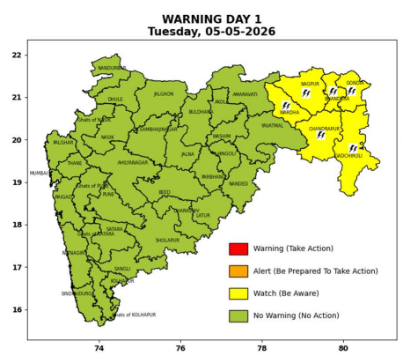 | 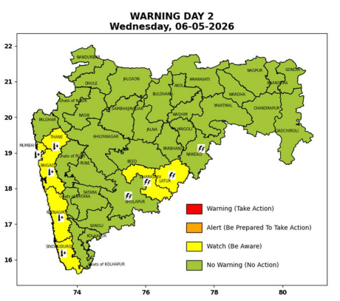 | 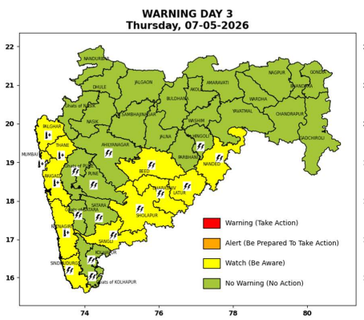 | 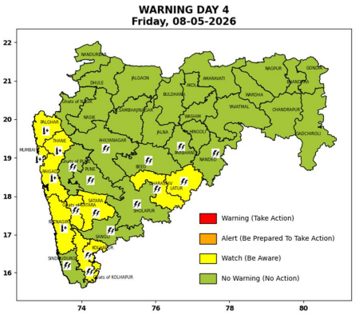 | 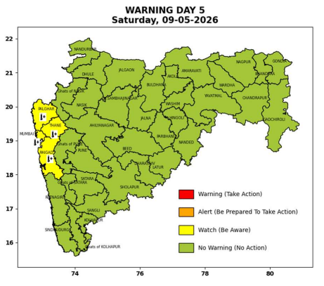

Pune, Lohegaon and Pashan observations at 0830 hrs. IST of Today
 | Temperature (°C) |  |  |  |  | Humidity (%) |  |  |  | Rainfall (mm)
 | Max.  past  24 hrs | Dep.  from  normal | Min.  past  24 hrs. | Dep.  from  normal | Dry  Bulb | At 0830 hrs. IST | Dep.  From  normal | At 1730  hrs. IST of y’day | Dep.  from  normal | Past  24 hrs. | Since  1st March | Dep.  from  normal
PNE | 37.4 | -1.1 | 22.8 | 1.2 | 26.8 | 68 | 18 | 22 | -6 | 0.0 | 92.8 | 74.4
PSN | - | - | - | - | - | - | - | - | - | - | - | -
LHG | 39.6 | 1.6 | 23.3 | 2.3 | 28.7 | 55 | 2 | 16 | -11 | 0.0 | 91.4 | 69.1

 |  |  |  |  |  |  | Local (Pune and neighbourhood) forecast
Max./Min. Temperature (°C) |  |  |  |  |  |  |  |  | Weather
Date | Pune | Pashan | Lohegaon | Chinchwad | Lavale | Magarpatta | NDA | Koregoan park
05/05/26 | 37 / 22.8* | 37 / - | 39 / 23.3* | 36 / 23.4* | 37 / 20.0* | 39 / 24.7* | 37 / 18.9* | 39 / 24.7* | Mainly clear sky.
06/05/26 | 37 / 23 | 37 / 23 | 39 / 23 | 36 / 23 | 37 / 20 | 39 / 25 | 37 / 19 | 39 / 25 | Mainly clear sky.
07/05/26 | 38 / 23 | 38 / 23 | 40 / 23 | 37 / 23 | 38 / 20 | 40 / 25 | 38 / 19 | 40 / 25 | Mainly clear sky
08/05/26 | 38 / 23 | 38 / 23 | 40 / 23 | 37 / 23 | 38 / 20 | 40 / 25 | 38 / 19 | 40 / 25 | Mainly clear sky
09/05/26 | 38 / 24 | 38 / 24 | 40 / 24 | 37 / 24 | 38 / 21 | 40 / 26 | 38 / 20 | 40 / 26 | Mainly clear sky
10/05/26 | 37 / 24 | 37 / 24 | 39 / 24 | 36 / 24 | 37 / 21 | 39 / 26 | 37 / 20 | 39 / 26 | Mainly clear sky
11/05/26 | 37 / 24 | 37 / 24 | 39 / 24 | 36 / 24 | 37 / 21 | 39 / 26 | 37 / 20 | 39 / 26 | Mainly clear sky
Rainfall Distribution |  |  |  |  | Rainfall Categories | Rainfall (mm) | Cloud condition |  | Rainfall Intensity | Range
Widespread (W) | 76-100% |  |  |  | Very Light rain | Trace to 2.4 mm | Mainly clear sky | 1-2 oktas | Light Spell | 1 cm/hr
 |  |  |  |  | Light rain | 2.5 to 15.5 mm | Partly cloudy sky | 3-4 oktas | Moderate Spell | 1-2 cm/hr
Fairly Widespread (FW) | 51 – 75% |  |  |  | Moderate rain | 15.6 to 64.4 mm | Generally cloudy sky | 5-7 oktas | Intense Spell | 2-3 cm/hr
Scattered (S) | 26 – 50% |  |  |  | Heavy rain | 64.5 to 115.5 mm | Overcast | 8 oktas | Very Intense Spell | 3-5 cm/hr
Isolated (I) | 1 – 25% |  |  |  | Very heavy rain | 115.6 to 204.4 mm |  |  | Extremely Intense Spell | 5-10 cm/hr
Dry (D) | No Rain |  |  |  | Extremely heavy rain | ≥ 204.5 mm |  |  | Cloudburst | > 10 cm/hr
Probability Terms in %: |  |  |  |  | Heavy snow | 6.5 to 11.5 cms water equivalent of rain
unlikely | < 25 |  |  |  | Very heavy snow | 11.6 to 20.4 cms water equivalent of rain
likely | between 25 50
very likely | between 51 75
most likely | >75
* = realized temperatu
Mumbai (Colaba) |  |  |  | Nagpur (AP)
Date 2026 | T max °C | T min °C | Weather | T max °C | T min °C | Weather
05/05/26 | 35 | 27 | Clear sky. | 43 | 24 | Thunderstorm with rain. Thunderstorm accompanied with lightning & gusty winds(40-50 kmph).
06/05/26 | 35 | 27 | Mainly clear sky. Hot and Humid. | 43 | 26 | Partly cloudy sky.
07/05/26 | 36 | 28 | Clear sky. Hot and Humid. | 43 | 26 | Partly cloudy sky.
08/05/26 | 36 | 28 | Clear sky. Hot and Humid. | 43 | 26 | Partly cloudy sky.
09/05/26 | 35 | 29 | Mainly clear sky. Hot and Humid. | 44 | 26 | Partly cloudy sky.
10/05/26 | 35 | 29 | Mainly clear sky. | 43 | 26 | Mainly clear sky.
11/05/26 | 35 | 29 | Mainly clear sky. | 44 | 26 | Mainly clear sky.

